Poppy Campaign Social Media Posts

Right-click the image and “Save as Picture” to your computer.

Post 1 of 2

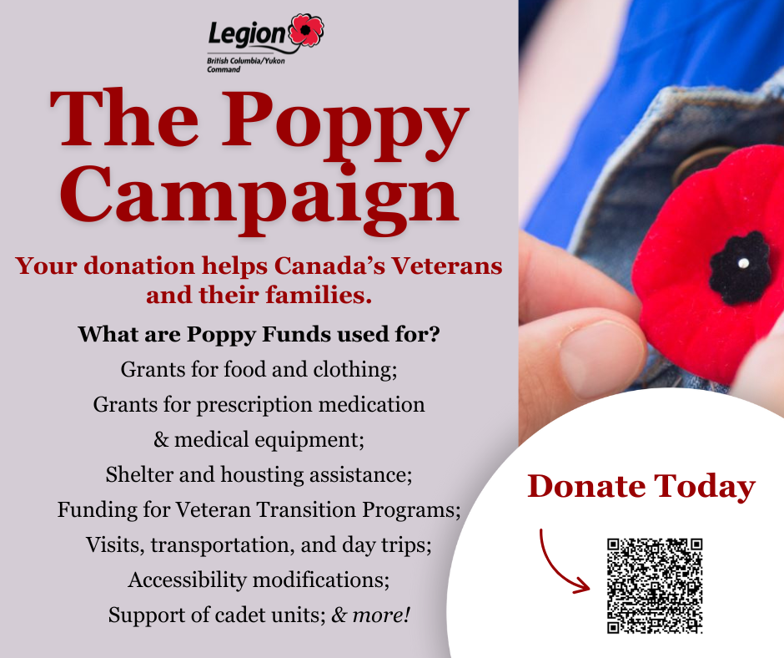

See next page.

Post 2 of 2

