**Facebook Ads**

**Created by the BC/Yukon Command Membership Committee**

**(6-Page Document)**

**Instructions for Saving the Images as JPGs or PNGs:**

1. In the Word Doc, right-click on the image you’d like to save.
2. Click “Save as Picture.”
3. In the pop-up window, select the folder on your computer where you’d like to save the image.
4. Under “File Name,” create a title for the image.
5. Under “Save as Type,” we recommend saving the image as either a “PNG” (Portable Network Graphics) or “JPEG.”
6. Click “Save.”

If you need help, please don’t hesitate to contact us at:

Email: [info@legionbcyukon.ca](mailto:info@legionbcyukon.ca)

Phone: (604) 575-8840

**Ad #1: “Adding to the Ranks”**

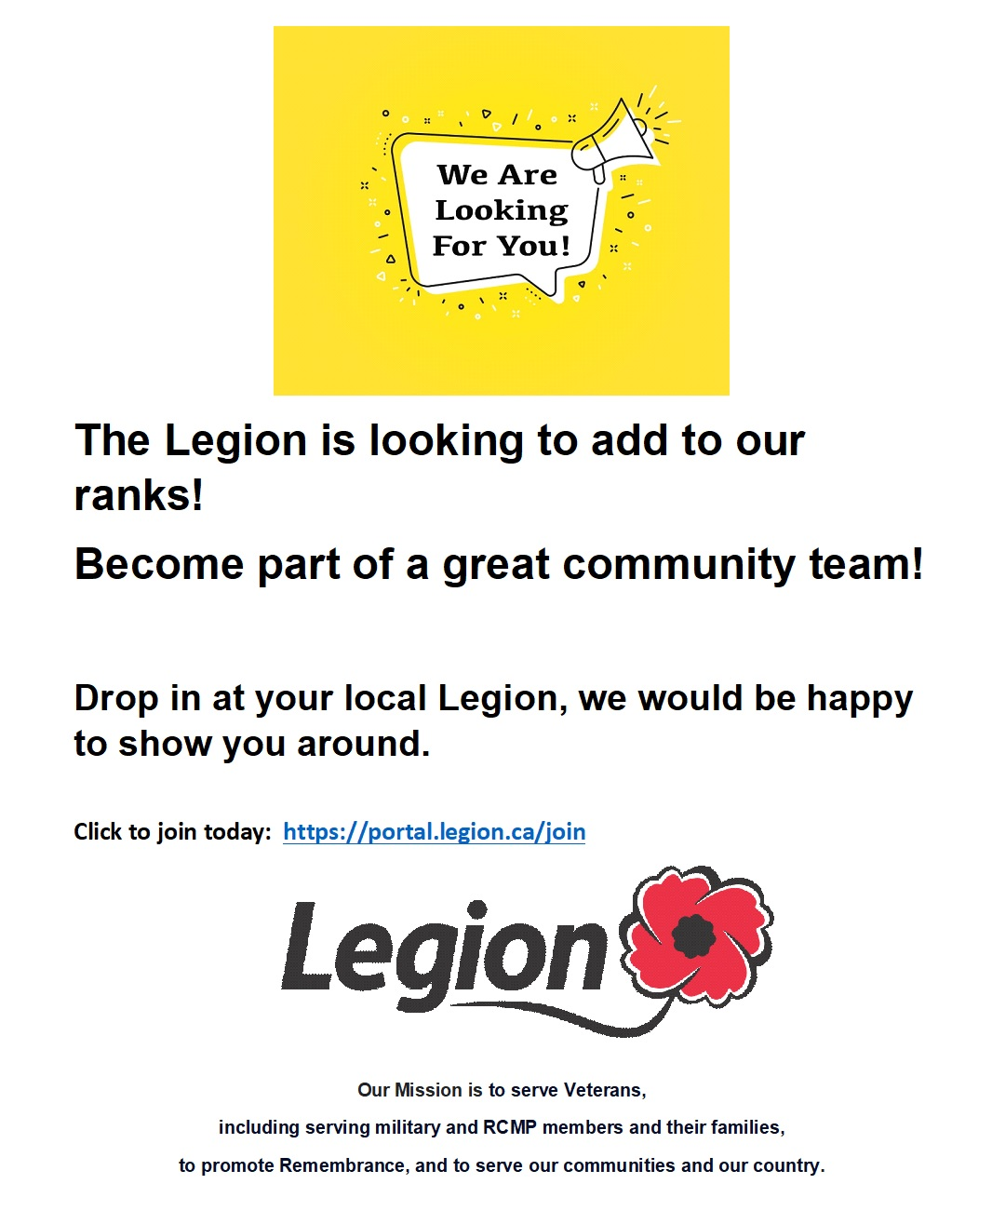

**Ad #2: “Friendship”**

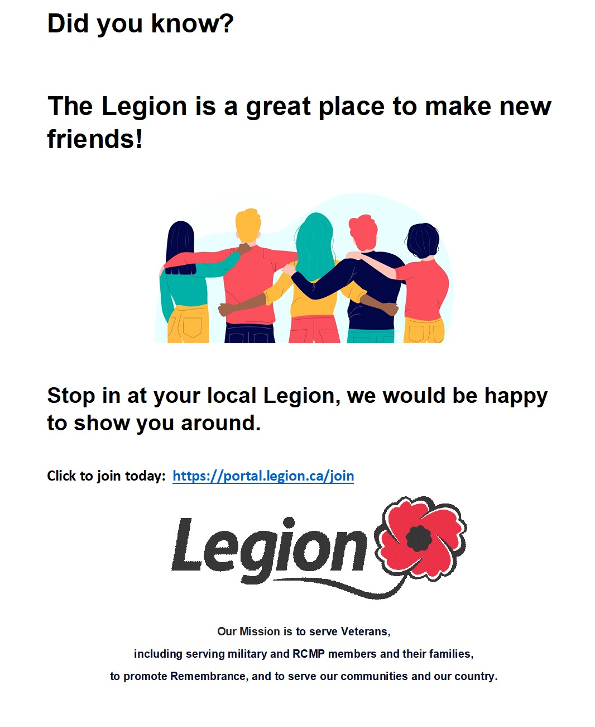

**Ad #3: “MEDIPAC”**



**Ad #4: “Memberperks”**

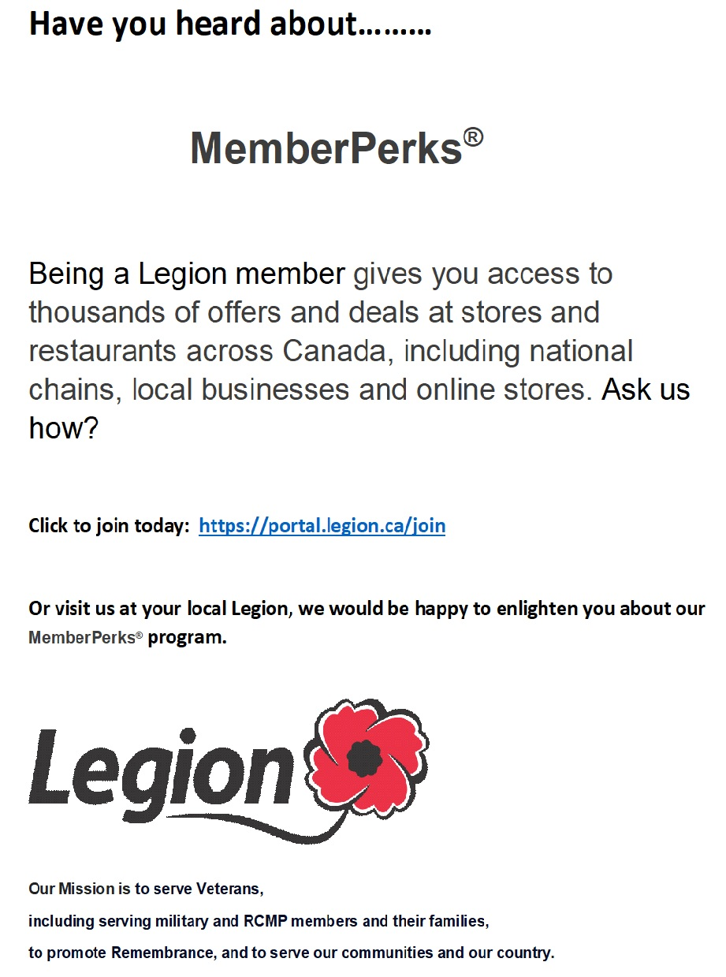

**Ad #5: “Volunteer”**

